**Pratima Bhattarai**

**Lab 3**

The IP address of my computer is 192.168.0.29 which is shown in the figure below.

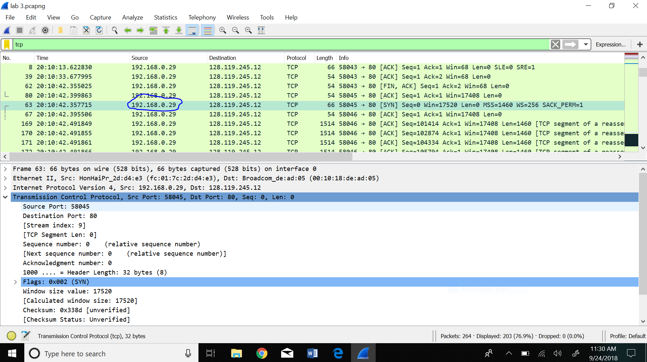

1. What is the TCP port number used by your computer to communicate with gaia.cs.umass.edu?

The TCP port number used by my computer to communicate with gaia.cs.umass.edu is port 58045.

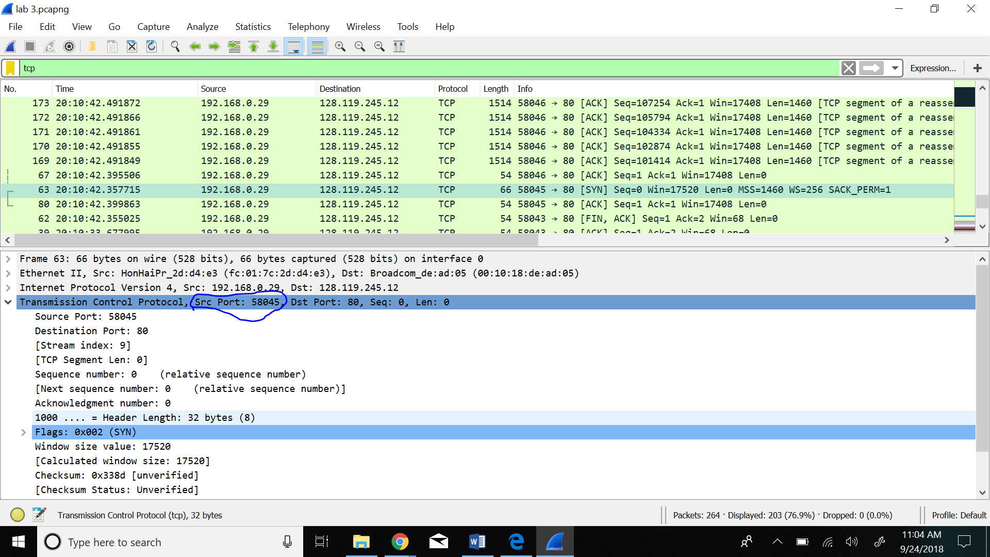

1. What is the TCP port number used by gaia.cs.umass.edu to communicate with your computer?

The TCP port number used by gaia.cs.umass.edu to communicate with my computer is port 80.

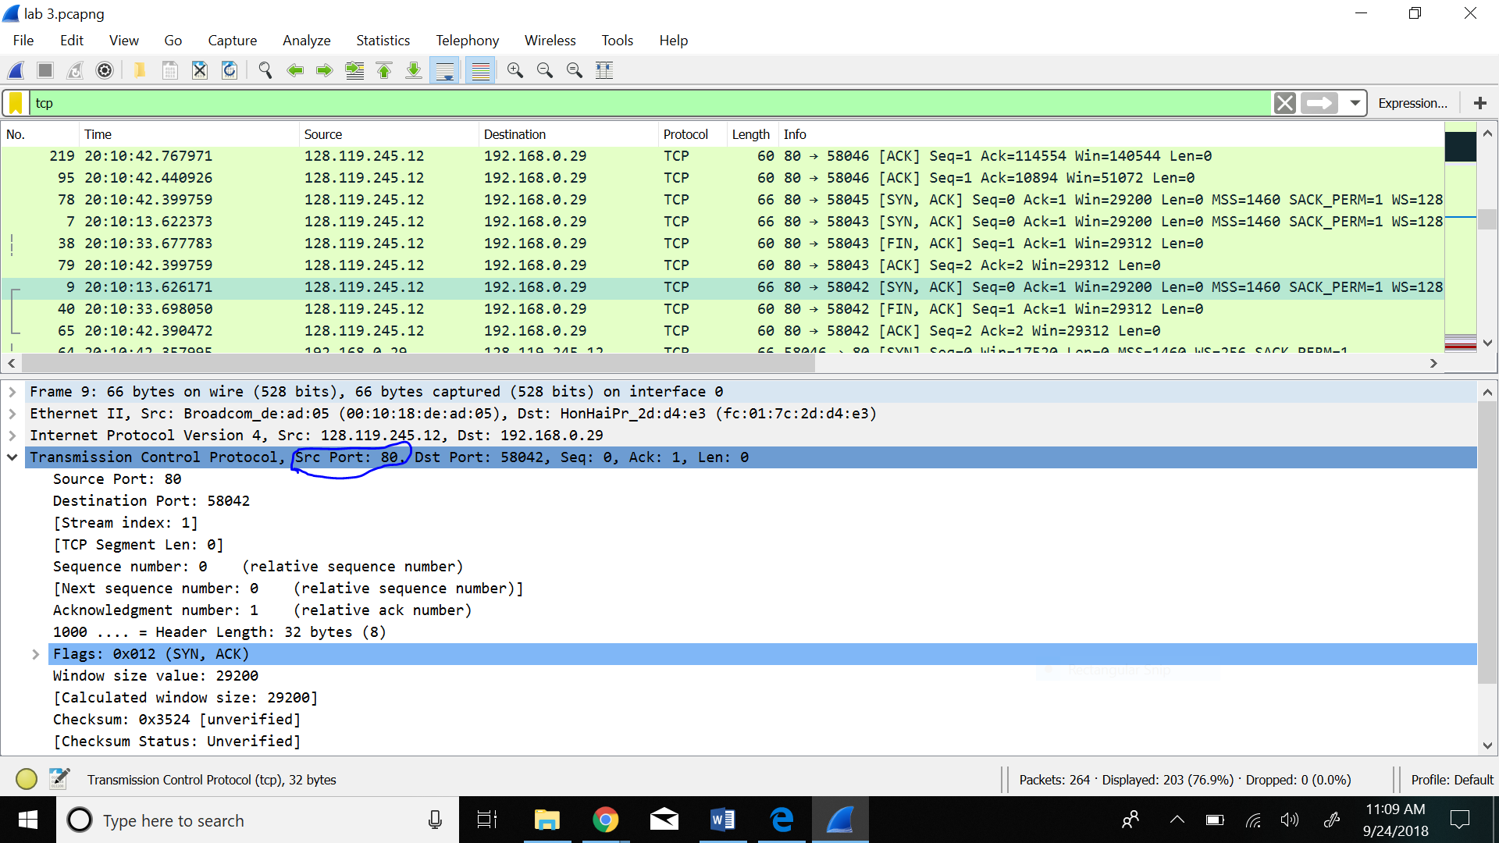

1. What is the sequence number of the TCP SYN segment that is used to initiate the TCP connection between your computer and gaia.cs.umass.edu? What is it in the segment that identifies the segment as a SYN segment?

The sequence number of the TCP SYN segment that is used to initiate the TCP connection between my computer and gaia.cs.umass.edu is 0. Sequence number being 0 indicate that it is a SYN segment and we can also see that acknowledgment made by our computer is 0 which shows it is the first in sending the request.

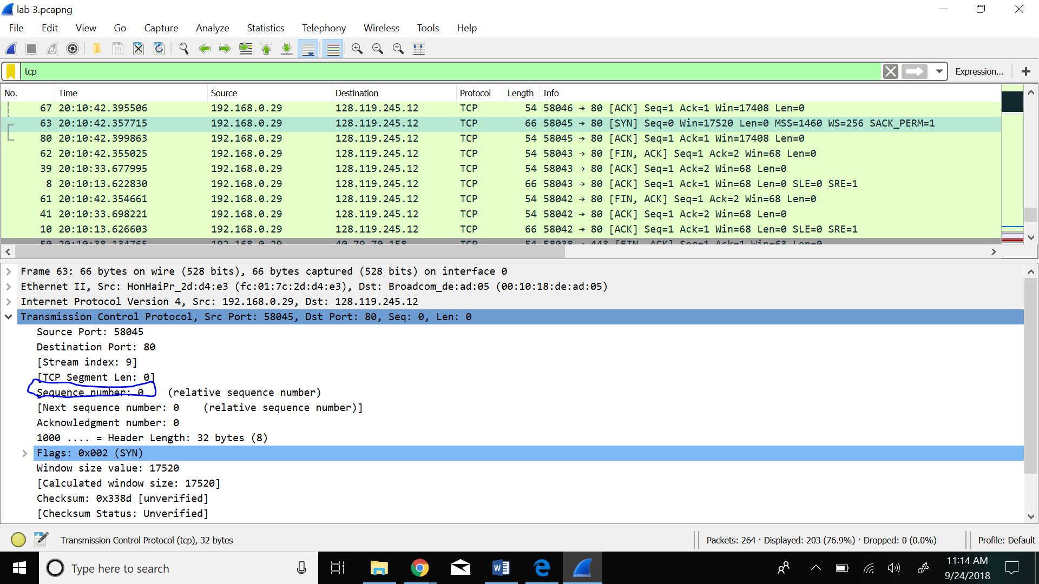

1. What is the sequence number of the SYNACK segment sent by gaia.cs.umass.edu to the client computer in reply to the SYN ?- You must dig deep and find the ACK from gaia.cs.umass.edu.

The sequence number of the SYNACK segment sent by gaia.cs.umass.edu to the client computer in reply to the SYN is 0. Similarly, acknowledgment is 1.

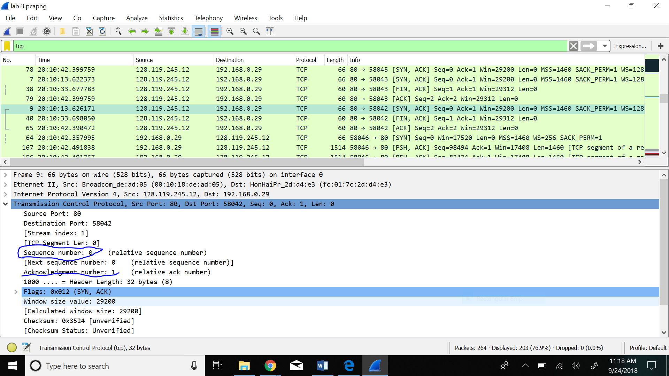

1. What is the sequence number of the TCP segment containing the HTTP POST command? Note: that to find the POST command, you’ll need to dig into the packet content field at the bottom of the Wireshark window, looking for a segment with a “POST” within its DATA field.

The sequence number of the TCP segment containing the HTTP POST command is 131199.

